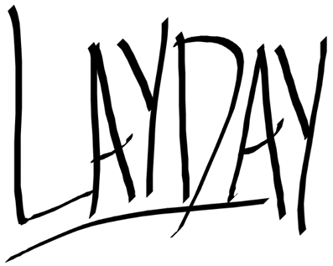

OKTOBERFEST AT LAY DAY: PROST IN PARADISE
Beer. Games. Pool. Music. Party.
FRIDAY OCTOBER 2ND 2026

EVENT CONCEPT
Oktoberfest at Lay Day: Prost in Paradise brings the fun of Oktoberfest into a Lay Day Friday pool party.
Rather than recreating a traditional German Oktoberfest, the event will take the recognisable elements of Oktoberfest, beer, drinking games, snacks and turn them into a full day Lay Day party.
The Beer Olympics will be the main activation, giving guests a reason to get involved, compete and interact throughout the afternoon.
The goal is simple: beer, games, pool, music and a lot of fun.

BEER OLYMPICS
The Beer Olympics will be the main activity of the afternoon.
Guests can sign up in teams and compete across a series of fun, fast-paced beer-themed games.

Potential Games
Bintang Beer Pong
Tournament-style beer pong with teams competing against each other.
Flip Cup
A classic team game that is easy for everyone to understand and join.
Pool Beer Relay
A team race involving a series of simple challenges.
Spin the Bintang
A spinning wheel at the bar with different challenges, prizes and drinking-related outcomes.
The final games can be selected based on the space, equipment and overall event flow.

Beer Olympics Format
Guests register in teams of approximately 4 to 6 people.
Each challenge earns teams points, with scores tracked throughout the afternoon.
The highest-scoring team at the end of the competition wins.

Potential Prizes
- Free drinks
- Lay Day merchandise

HAPPY HOUR BINTANG BUCKETS ALL DAY

ROAMING GERMAN SNACKS
TBC with Chef Nick

DECORATION & VISUAL IDENTITY
The visual direction should combine Oktoberfest with the existing Lay Day pool party atmosphere, rather than trying to recreate a traditional German beer hall.

Key Elements
- Oktoberfest inspired flags
- Beer-themed props
- Poolside decorations
- Large PROST IN PARADISE signage
- Beer hats and fun beer accessories

MUSIC
Music will remain consistent with the normal Lay Day Friday party.
The event does not rely on German music, as the majority of guests are unlikely to be German or familiar with traditional Oktoberfest songs.
The DJ can incorporate occasional Oktoberfest moments throughout the day while keeping the main soundtrack focused on the music that already works for the Lay Day crowd.
Reggaeton + commercial party music + Oktoberfest moments.

